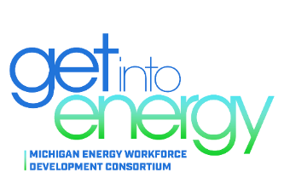
Michigan Energy Workforce Development Consortium (MEWDC)
Membership Meeting
Friday, November 18, 2022
12:50 p.m. – 1:20 p.m.
MIAT College of Technology
2955 Haggerty Rd
Canton, MI 48188

www.careersinenergymichigan.com

LEADERSHIP TEAM

Christopher HooSang Co-Chair
DTE Energy

Sharon Miller Co-Chair
Consumers Energy

Amber Fogarty Vice Chair
Consumers Energy

Deborah Majeski Vice Chair
DTE Energy

Breina Pugh Vice Chair
Lansing Board of Water & Light

Gail Wahlberg Vice Chair
Enbridge

Katie Abraham
Michigan Municipal Electric Association

Chris Davis
MIAT College of Technology

David Gard
Michigan Energy Efficiency Contractors

Deb Lyzenga
Michigan Department of Labor and Economic Opportunity (LEO)

Carrie Rosingana
Capital Area Michigan Works!

Joseph Saur
Michigan Veterans Affairs

Marcia Black- Watson Director
MEWDC

AGENDA

12:40-12:50 pm Center for Energy Workforce Development Update
- Kristie Kelley | Workforce Development Director |
Center for Energy Workforce Development

12:50-1:00 pm MEWDC Update – 2022 Accomplishments
- Chris HooSang | Director, Corporate HR | DTE Energy

1:00-1:10 pm Careers in Energy Week 2022 Reflections
- Callie Curtis | Strategic Talent Pipeline Coordinator|
Consumers Energy
Amber Fogarty |Manager, Talent Pipeline, DEI |
Consumers Energy
Alicia Harris | Manager, Employment Strategies & Compliance | DTE Energy

1:10-1:20 pm Diversity Focus Groups & Digital Campaign
- Lisa Assenmacher | Director of Brand Strategy |
Piper & Gold Public Relations

1:20-1:30 pm Break

